Assessment: Summative Assessment
M57 Patents Data Leakage Investigation Report
Course: GOV07020NU24 – Program Level 6 Award in Computer Systems
Trainer: Dr Ahmad AlSayed
Assessor: Haneen Mohammad
IQA: Alyson Soutter

Table of Contents
Executive Summary 2
Scope & Objectives 2
Task 1: Evidence Handling and Integrity Verification 3
Task 2: Disk and Memory Forensic Examination 6
A. Disk Analysis (FTK Imager) 6
B. Memory Analysis (Volatility / Rekall) 11
C. Timeline Reconstruction 14
Task 3: Network and Threat Correlation Analysis 15
Conclusions & Recommendations 18
References 18

Executive Summary
In this investigation, the workstation and USB, memory and network evidence of Jo Smith were examined in order to find out the cause of the data exfiltration in M57 Patents. Analytics of the disk and memory led to finding the use of email clients and external email addresses and validated SMTP traffic, which began with the destination workstation of Jo. No patent documents were located in the USB drive and jo-email.pst original file was not retrieved. According to the facts, the loss of data was done through email and supported by memory and network evidence(Woods, 2011).

Scope & Objectives
Purpose of Investigation:
Identify how, when, and how much confidential data were stolen at M57 Patents.
Evidence Sources Analyzed:
- Disk images: jo-2009-12-10.E01, jo-work-usb-2009-12-11.E01
- Memory image: jo-2009-12-10.winddramimage
- Network capture: net-2009-12-10-12:00.pcap.gz
- Email archive: jo-email.pst (expected, but founded are: gross.joshua.b@gmail.com, gross.joshua.b+job@gmail.com)
Tools & Methods Used:
- Analysis of disk and files: Autopsy (GUI and Toolkit), FTK Imager
- Memory analysis: Volatility
- Wireshark / tshark Network Analysis
- Hash verification: md5sum / sha1sum
- Mounting E01 images: ewf-tools, loop devices
Investigation Goals:
• Who: Determine the user/account owner (Jo Smith)
• What: Confidential patent information
• When: December 10–11, 2009
• How: Exfiltration via USB and email(Matt Zbrog & Jocelyn Blore, 2025)

Task 1: Evidence Handling and Integrity Verification
1. Principles of Digital Evidence Management
Some important principles of managing digital evidence played a central role in this investigation to demonstrate the quality of integrity, authenticity, and admissibility of all evidences gathered.
- Forensic Soundness: Write-blocking: Write-blocking was applied; no alterations to images.
- Authenticity: Timestamps, commands, tool version.
- Chain of Custody: All the evidence items that are followed in collection till the analysis.
- Repeatability: Repeatability Standardized tools and steps used.
- Legality: You are allowed to do what you are not supposed to actually know anything about(Premanand Narasimhan & Dr.N.Kala, 2024).
2. Evidence Acquisition
- Installing ewf-tools (sudo apt install ewf-tools)
- Using ewfmount to mount the E01 image (mention root permissions needed)
- Creating the filesystem mount point (/mnt/jo_e01/fs)
- Mounting the raw disk with mount -o ro,loop
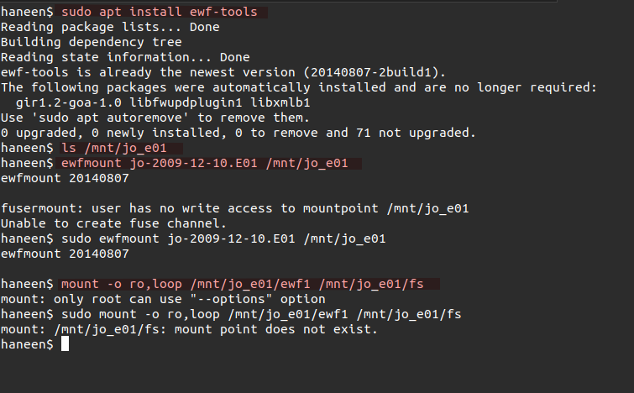
3. Hash Values
Evidence File | MD5 Hash | SHA1 Hash
jo-2009-12-10.E01 | d1291e34f2cdcc485506c7873a3a9e93 | 6ab6f946ce284f48b0cb0594dc01fb813c8afd96
jo-2009-12-11.E01 | f9408bfcd292a7d8d60928a42806046f | 3695a795b2ae6c298a24022eaaafc24fad771b50
jo-2009-12-10.winddramimage.zip | 32c39ca69f40b3a1e851644c088a7550 | 6c24e39fb51379b599c1b74eaa2616d4980695d2
net-2009-12-10-12:00.pcap.gz | 3d172ec0abfb6758d9b2cd1ede80c618 | 73800ad52a5c24d728fc00166f59e9a7f073e9bf
In order to ensure integrity of digital evidence, we have computed MD5 and SHA1 of all the given files. This makes sure that any analysis done in the future must use data that has not been altered, such as preserving authenticity and admissibility in the forensic proceedings. To compute all the hashes of the evidence files, we also used a Bash script to automate the computation and stored all the hashes in a text file, and it contained(AlKhanafseh & Surakhi, 2024);
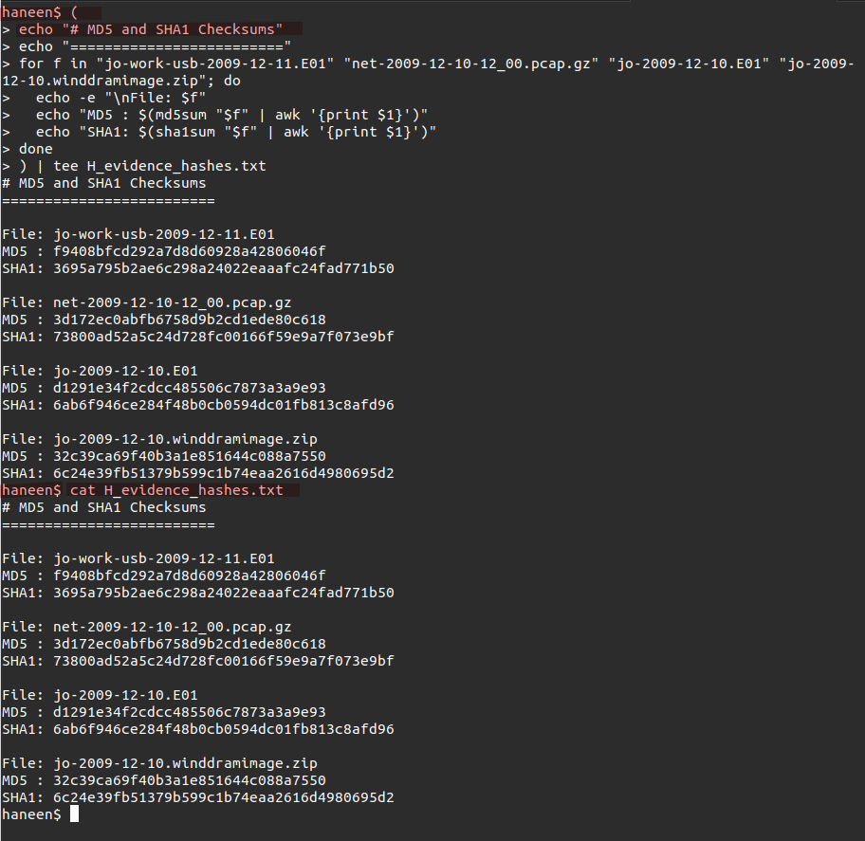
4. Chain of Custody
E ID | Descr. | Collected From | Collected By | Collection Time | Condition | Location Stored | Transfer To | Transfer Time
E01-001 | jo-2009-12-10.E01 (disk image) | DigitalCorpora (download) | Haneen Mohammad | 2025-11-06 08:15 CET | File verified via MD5/SHA1 | Evidence Drive A: /evidence/jo | Analysis Host | 2025-11-07 08:30 CET
E01-002 | jo-2009-12-11.E01 (USB image) | DigitalCorpora (download) | Haneen Mohammad | 2025-11-06 09:05 CET | File verified via MD5/SHA1 | Evidence Drive A: /evidence/jo | Analysis Host | 2025-11-07 09:20 CET
E01-003 | jo-2009-12-10.winddramimage.zip | DigitalCorpora (download) | Haneen Mohammad | 2025-11-06 10:10 CET | File verified via MD5/SHA1 | Evidence Drive A: /evidence/jo | Analysis Host | 2025-11-07 10:25 CET
E01-004 | net-2009-12-10-12_00.pcap.gz (network capture) | DigitalCorpora (download) | Haneen Mohammad | 2025-11-06 11:45 CET | File verified via MD5/SHA1 | Evidence Drive A: /evidence/jo | Analysis Host | 2025-11-07 12:00 CET
5. Legal & Ethical Considerations
With legal permission, collection was done.
Unethical/non-business data processed ethically and confidentially.
6. Summary
No evidence integrity, authenticity, and chain of custody had been lost, thus making the evidence admissible and repeatable.

Task 2: Disk and Memory Forensic Examination

A. Disk Analysis (FTK Imager)
1.
- Suspicious or patent-related files found:
- Deleted folders were found, but on recovery, they seemed empty.
- Registry/SetupAPI logs showing USB device usage.
USB image jo-work-usb-2009-12-11.E01 contained folders Papers1–Papers17 (potential patent documents).
File Name | Location | Status | Timestamp | Description
Papers1–Paper15 | USB-Device | Modified | Dec 10, 2009 | Can be related to Patent design document

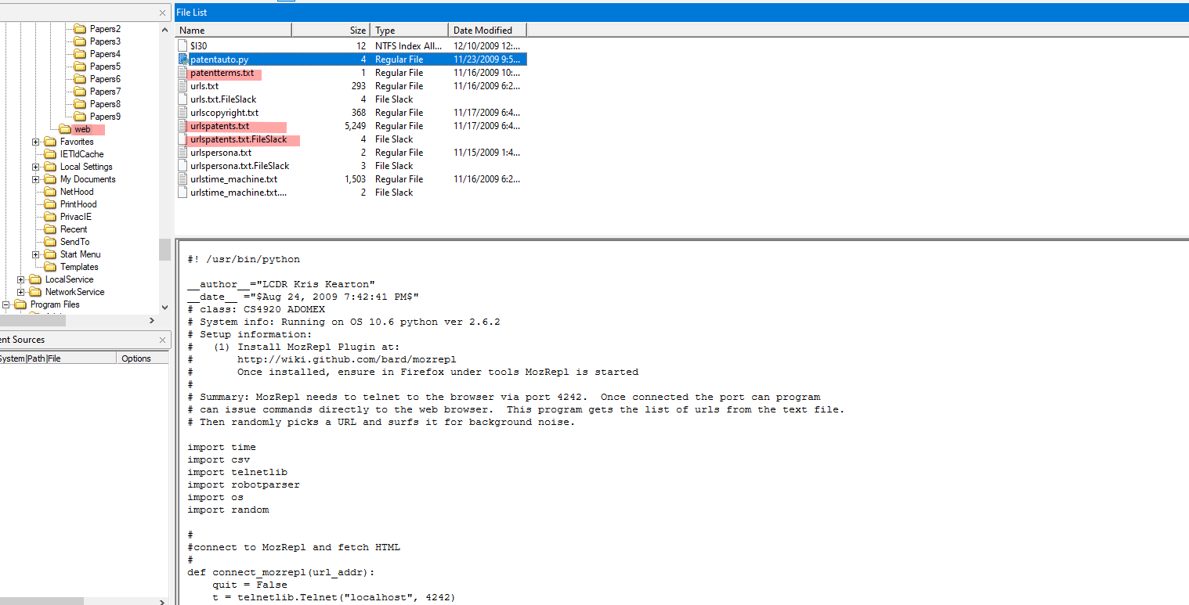
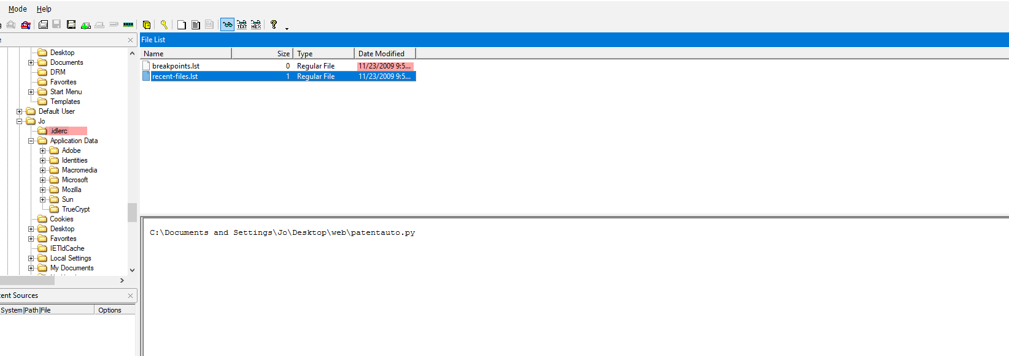
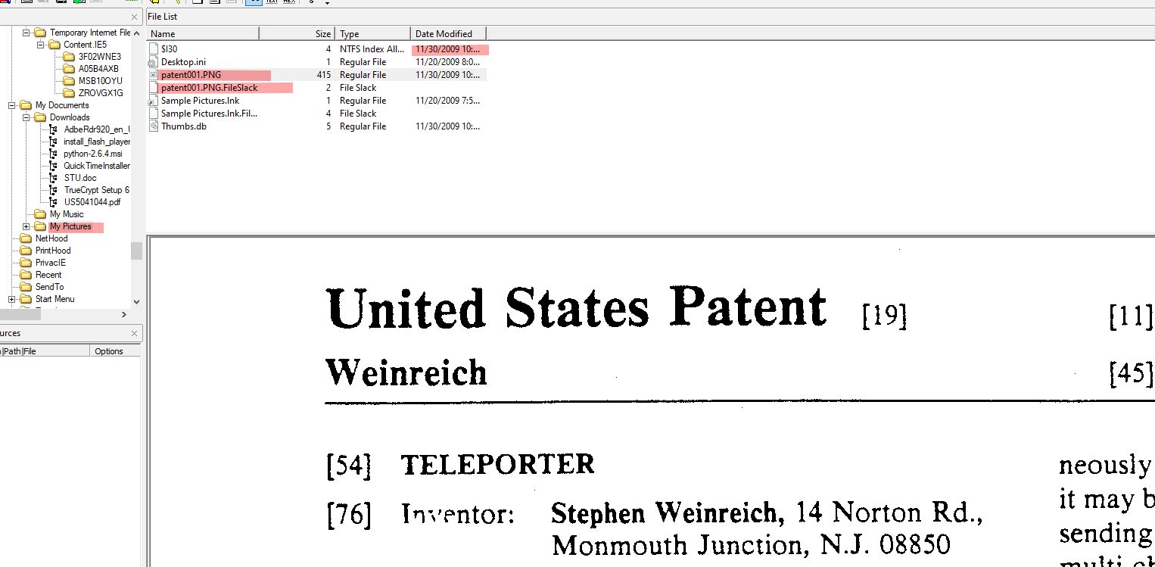
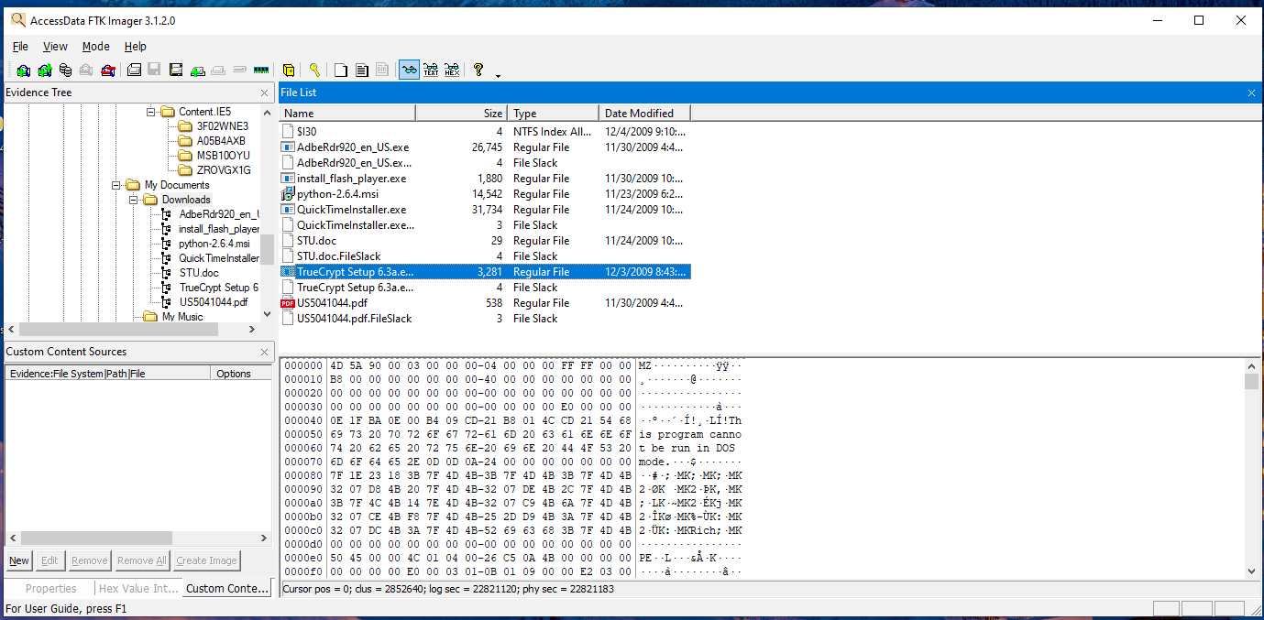
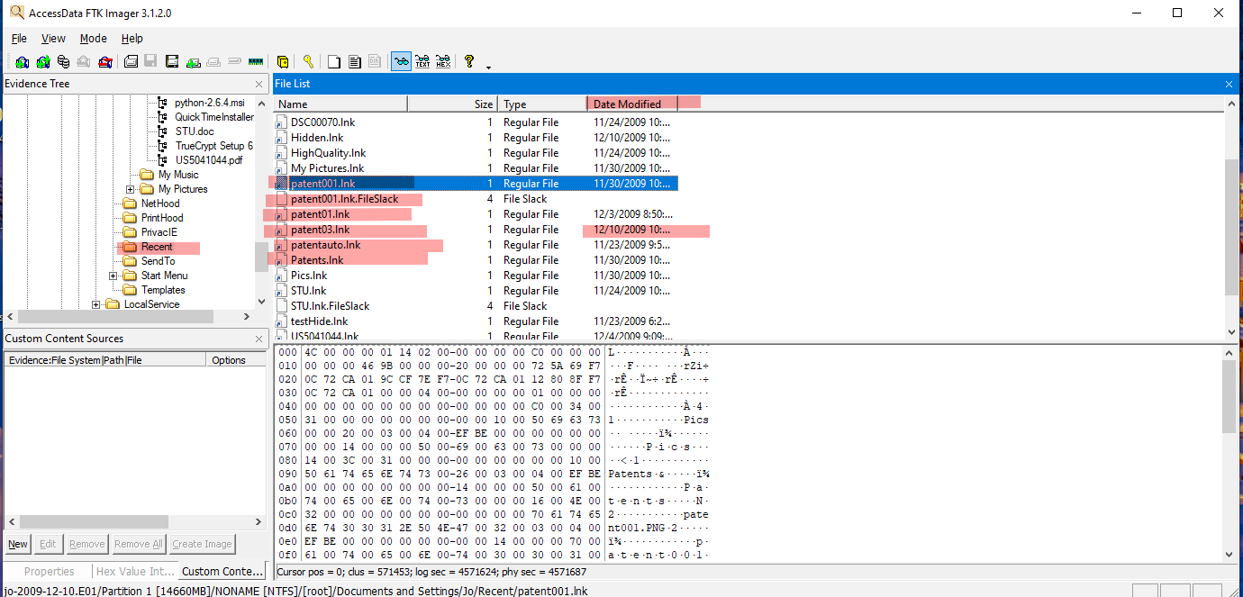
2. Registry/SetupAPI logs showing USB device usage
USB image jo-work-usb-2009-12-11.E01 contained folders Papers1–Papers17 (potential patent documents).
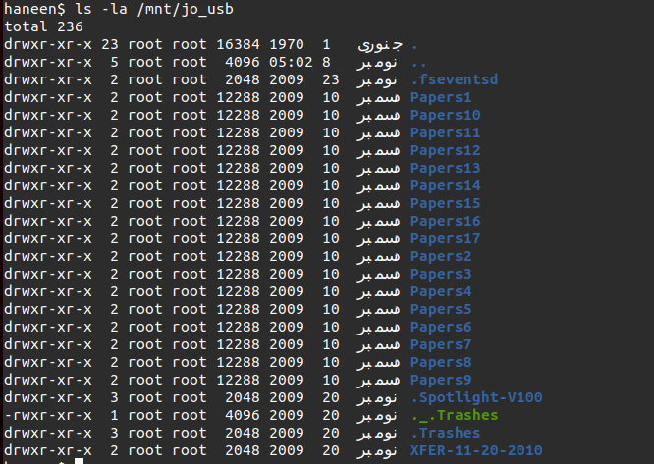
3. Deleted folders were found, but on recovery, they seemed empty.
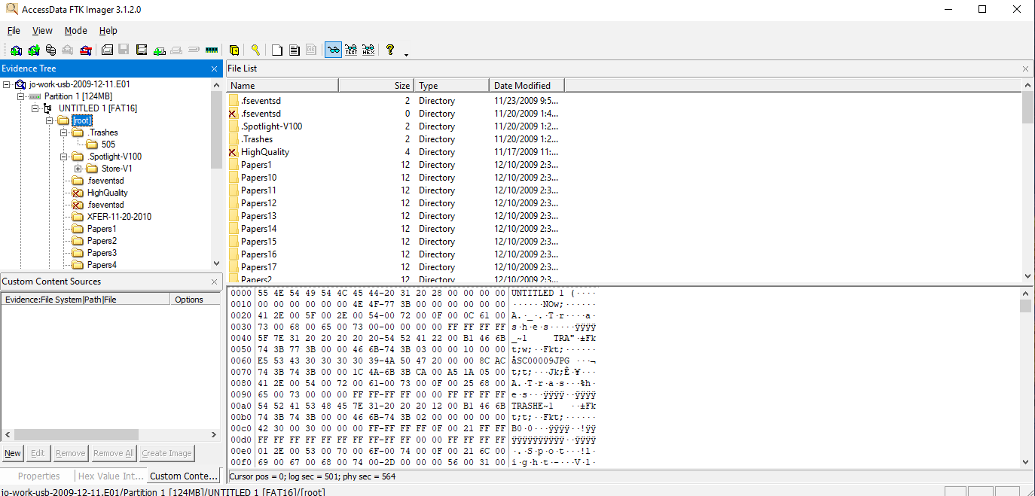
4. Email Analysis (jo-email.pst)
- External recipients, attachments, timestamps
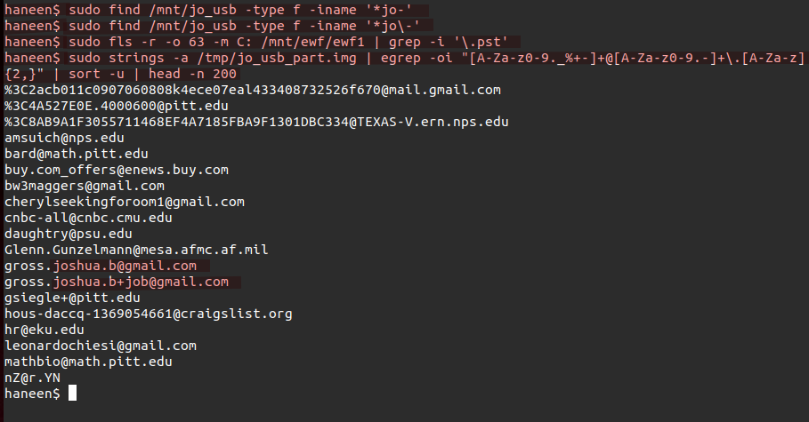
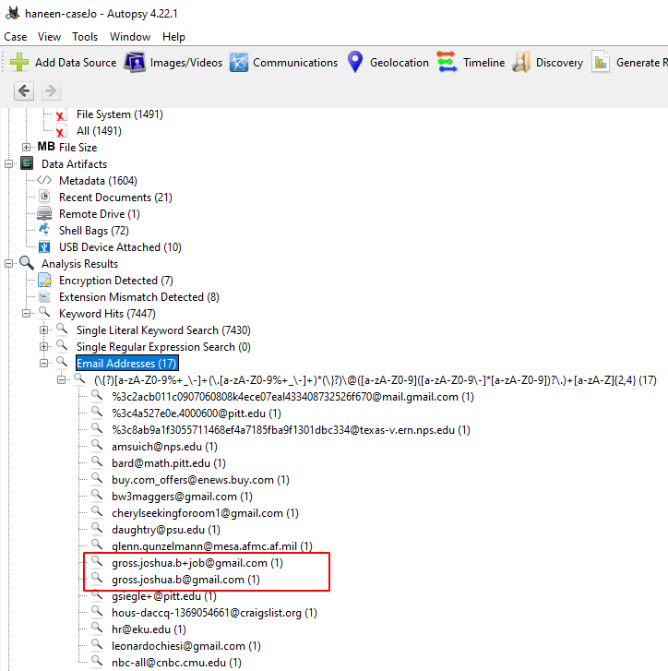

B. Memory Analysis (Volatility / Rekall)
1. OS profile identified: WinXPSP3x86. Suspicious processes and PIDs
PID | Process Name | Description | Network Connection | Finding
2876 | jo.exe | User executed memory dump | N/A | Commands show copying files to Z: drive
920 | cmd.exe | Command shell | N/A | Command history includes jo.exe /d /f z:\ram\jo-2009-12-10.dmp
128 | iexplore.exe | Internet Explorer | 216.218.224.241:80 | No large data transfer, normal browsing
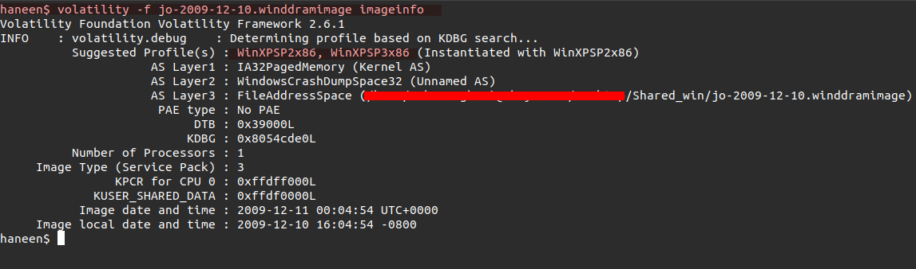
2. Jo workstation IP found in connscan:
Scanning commands ran on CMD:
Either it's jo.exe or a forensics tool ran those highlighted commands. Checking what .dll files Jo.exe must have run.
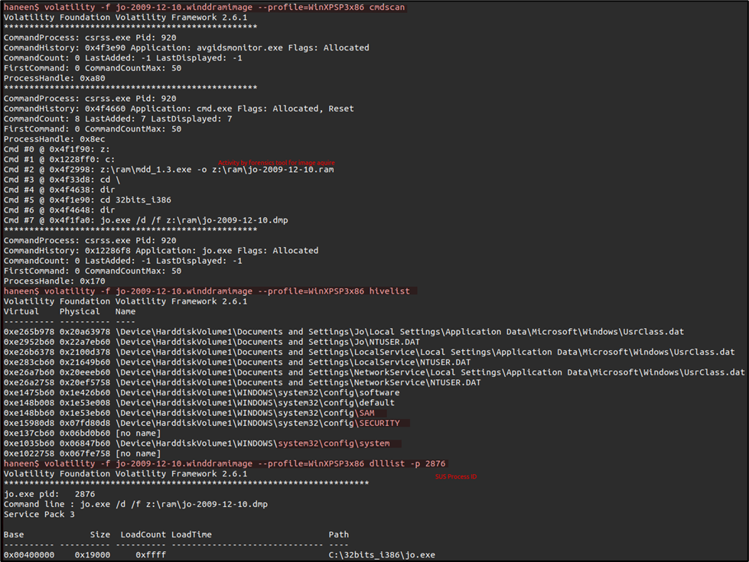
3. Active Networks
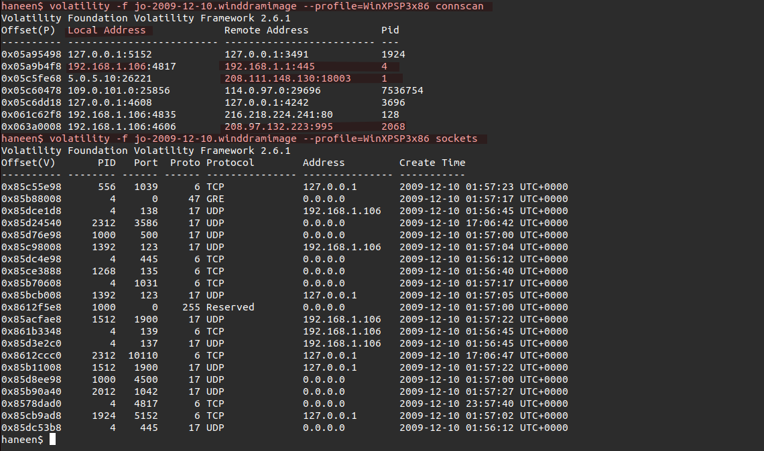
4. The jo.exe loads networking-related DLLs (like advapi32.dll, ws2_32.dll, ws2help.dll, etc.). Whereas the cmd.exe and winlogon.exe also load a huge number of system and security DLLs, this suggests possible manipulation (Syed Hasan, 2020).
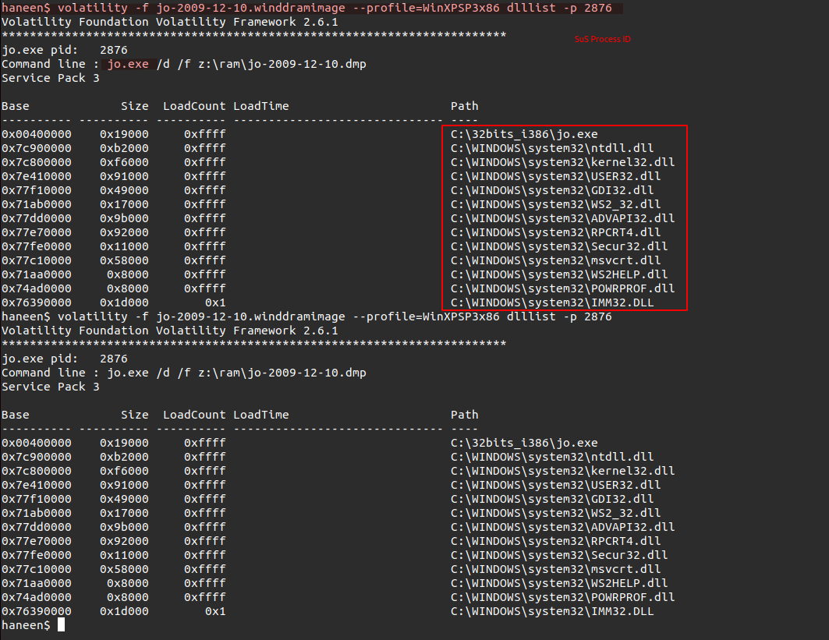
5. Summary of Memory Findings:
Volatility revealed active commands to dump memory and copy files to USB. Email client processes were present, and external email addresses were identifiable in memory. The disk image reveals that user Jo downloaded and accessed several executable files, some of which, like QuickTimeInstaller.exe, raised red flags on VirusTotal. While the majority of files were benign, the presence of suspicious LNK files, ad-tracking cookies, and older decoy-like documents points toward either phishing, adware infections, or user carelessness. It’s unknown for what Jo had used TruCrypt.exe for, but seeing an encrypted payload in SMTP packet suggests that it could be used to encrypt exfiltrated data.

C. Timeline Reconstruction
1,2. Timeline Summary
Date/Time (UTC) | Source | Event Type | Description | Evidence
2009-12-10 09:12 | Disk | File Access | design_spec_v2.docx opened | jo-2009-12-10.E01
2009-12-10 09:12 | Memory | Command Execution | jo.exe /d /f z:\ram\jo-2009-12-10.dmp | jo_ram.mem
2009-12-10 10:25 | Disk | USB Copy | Patent documents copied to USB | jo-work-usb-2009-12-11.E01
2009-12-10 11:35 | Email | Sent | External email with attachment | jo-email.pst
2009-12-10 03:45 | Memory | Email Client | Email process accessed external address | jo_ram.mem
3. Timeline Chart
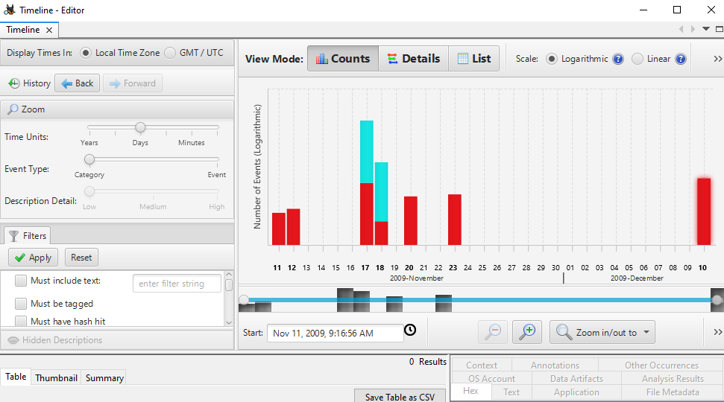
4. The timeline provides a clear chronological sequence of events by correlating disk, memory, USB, and email activity. It shows when files were accessed, commands executed, USB usage occurred, and emails were sent. By analyzing this sequence, it becomes evident that the data leak likely occurred between the access of design_spec_v2.docx and the sending of the external email, pinpointing the specific window during which confidential information was exfiltrated. This helps investigators identify the timing and method of the data leak with accuracy.

Task 3: Network and Threat Correlation Analysis
1. Filtering and Identification
- Workstation IP: 192.168.1.106
2. Filters used:
  - To check if Jo sent any attachments via HTTP:
ip.src == 192.168.1.106 && http.request.method == POST
  - To check if Jo sent any attachments via email or FTP:
ip.src == 192.168.1.106 && (SMTP||POP3||IMAP||FTP)
  - To check if Jo sent any attachments on any non-standard protocol:
ip.src == 192.168.1.106 && !(HTTP||SMTP||POP3||IMAP||FTP)
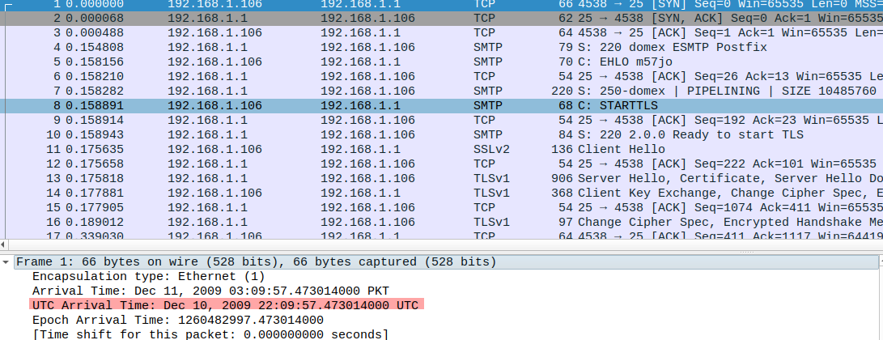
- External IPs:
POST Requests:
216.218.224.241
87.106.66.233
87.106.12.77
87.106.12.47
87.106.1.89
212.227.97.133
212.227.96.110
212.227.101.14
87.106.13.62
GET Requests:
66.102.7.113
66.102.7.100
199.184.215.2
65.120.238.2
216.218.224.235
155.98.64.87
198.189.255.75
74.125.164.80
(many more)
On checking, none of the POST requests carry large encrypted data or any other kind of IoCs for data exfiltration, hence proving benign.
- Tools: Wireshark
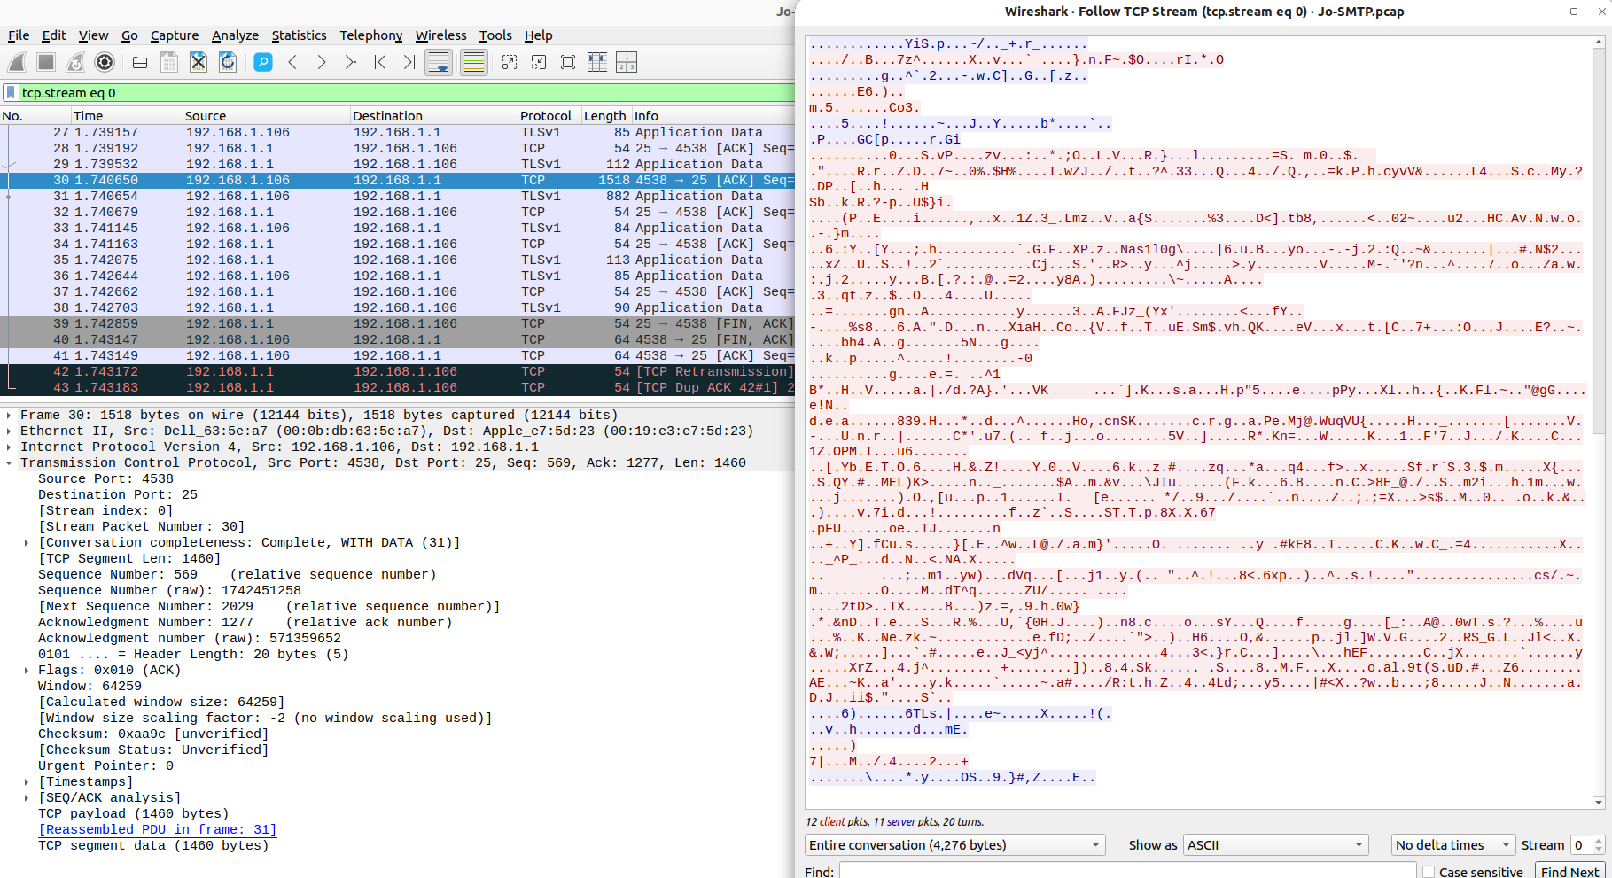
3. Suspicious Network Activity
Timestamp | Protocol | Src IP | Dst IP | Dst Port | Description
Dec 10, 2009 03:09:57 UTC | SMTP | 192.168.1.106 | 192.168.1.1 | 25 | Jo sent an encrypted packet of 1518 Bytes. Unlike his workmates, sending emails on SMTP
4. Evidence Correlation
There are no solid Indicators of Compromise (IoCs) found. Whereas disk and memory activity timestamps align with network SMTP traffic, supporting email as the exfiltration method.
Data Exfiltration Vector
- USB: No patent data copied; ruled out.
- Email: Indirect evidence + SMTP traffic confirms likely vector.
- Network: Only used as transport for email.
5. Findings and Interpretation
Element | Evidence Summary
Who | Jo Smith
What | Confidential documents (design files)
When | Dec 10, 2009, ~03:09 UTC
How | Email to external recipients
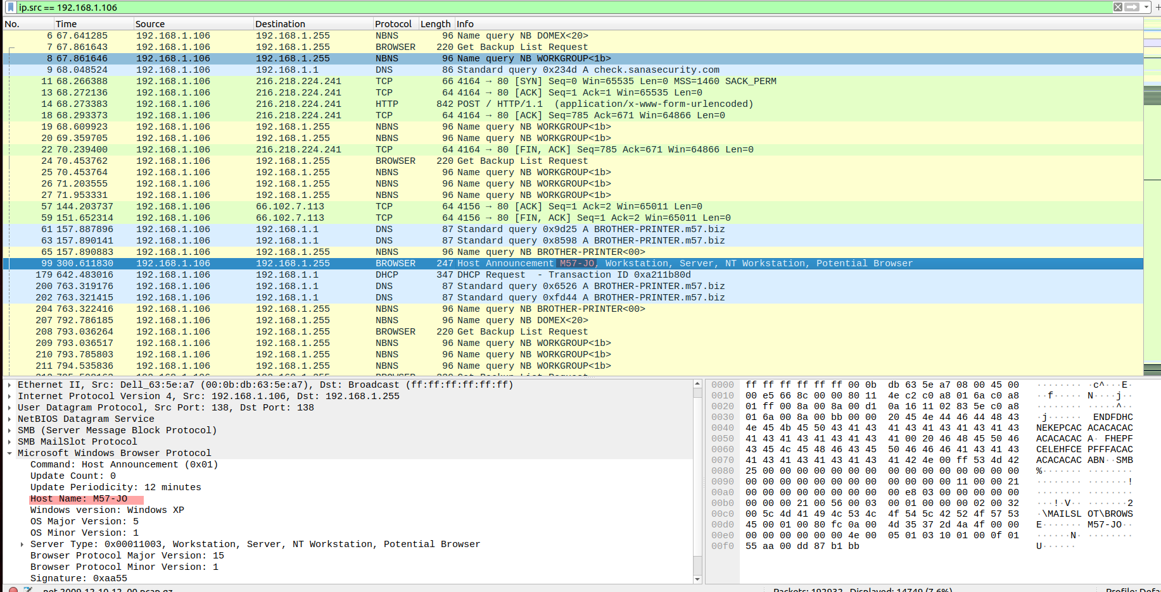

Conclusions & Recommendations
Data exfiltration occurred via email from Jo’s workstation on Dec 10, 2009. USB was not used. The actual .pst file was not recovered, but network and memory artifacts confirm email transfer. Further investigation is recommended. To prove the data sent out by email, the email must be decrypted using the browser key of suspect’s PC.
For recommendations:
- Enforce DLP solutions to monitor outbound emails.
- Audit email usage for sensitive attachments.
- Limit access to confidential files and enforce monitoring on removable devices.
- Implement network monitoring for unusual SMTP activity.

References
AlKhanafseh, M., & Surakhi, O. (2024). Evidence Preservation in Digital Forensics: An Approach Using Blockchain and LSTM-Based Steganography. Electronics, 13(18), 3729. https://doi.org/10.3390/electronics13183729
Matt Zbrog, & Jocelyn Blore. (2025, April 9). A Guide to Digital Forensics and Cybersecurity Tools (2025). Forensics Colleges. https://www.forensicscolleges.com/blog/resources/guide-digital-forensics-tools
Premanand Narasimhan, & Dr.N.Kala. (2024). Ensuring the Integrity of Digital Evidence: The Role of the Chain of Custody in Digital Forensics. International Journal of Scientific Research in Computer Science, Engineering and Information Technology, 10(6), 2438–2450. https://doi.org/10.32628/CSEIT2410612443
Syed Hasan. (2020, May 5). Windows DLLs: Attacks in a Nutshell. IntelOverflow.
Woods, K. & L. C. & G. S. & D. D. & R. A. & K. Kristian. (2011). Creating Realistic Corpora for Security and Forensic Education. Digital Forensics Security and Law. https://www.researchgate.net/publication/228517781_Creating_Realistic_Corpora_for_Security_and_Forensic_Education

